Overview
ILLINOIS MEDICAL EMERGENCY RESPONSE TEAM | 3
IMERT EXECUTIVE BOARD | 4
IMERT MEDICAL DIRECTOR | 5
PROGRAM OVERVIEW | 6-7
SIGNIFICANT ACTIVITIES | 8-9
PARTNERSHIPS | 10
COLLABORATIONS | 11
COMMITTEE MEMBERSHIP | 12

Response Capabilities
VOLUNTEER STATUS | 13
RECRUITMENT AND RETENTION | 14
COMMUNITY OUTREACH | 15
MEDICAL TEAM | 15
MISSION SUPPORT TEAM | 16
DEPLOYMENT RESPONSE PACKAGES | 17-18
ALTERNATE CARE SYSTEMS | 19

Training
TEAM TRAINING | 20
DEPLOYMENT OPERATIONS COURSE | 21-22
MOULAGE | 23
STOP THE BLEED | 24
Training
STAFF AND TRAINING TEAM | 24-25
ADDITIONAL TRAINING AND DEVELOPMENT | 26
OPERATION SOUTHERN SKY | 27-28
MASSAC COUNTY EXERCISE | 29

Equipment
EQUIPMENT | 30
PORTABLE ULTRASOUND | 31
EQUIPMENT MAINTENANCE | 32
ELLIOTT SYSTEMS DATABASE | 33
COMMUNICATIONS | 33
STARCOM | 34
COMMUNICATIONS EXERCISES AAR Summary | 34-37
SOLAR ECLIPSE SUMMARY | 37-39

ILLINOIS MEDICAL EMERGENCY RESPONSE TEAM

The Illinois Medical Emergency Response Team (IMERT) is a 501c3 not-for-profit organization of volunteers trained to respond to disasters and provide interim medical care for survivors or evacuees. This report provides an overview of the IMERT program and addresses deliverables from the FY 2018 ASPR Hospital Preparedness Program Grant provided to IMERT. This grant is used to enhance community resiliency by maintaining 24-hour operational readiness to lend medical assistance in times of disaster throughout the state of Illinois. Additionally, IMERT engages in activities that enhance community medical response capabilities through education and collaborative training to enhance the overall capability of the State of Illinois to respond to public health and medical disaster emergencies.
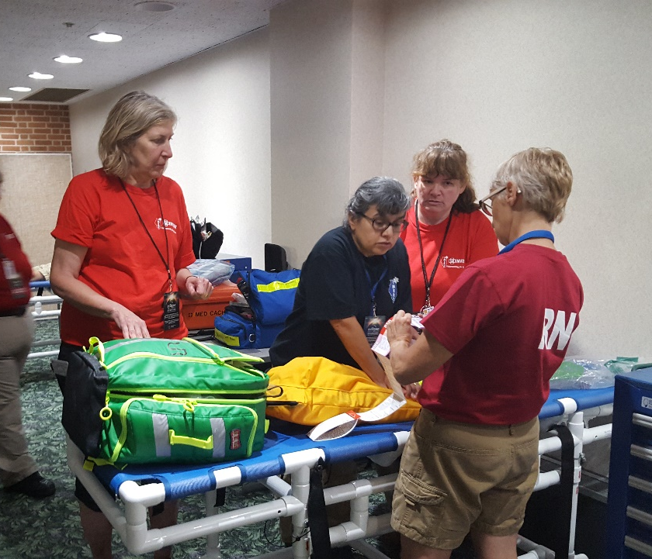 | IMERT’s Mission  IMERT works to support Illinois by maintaining 24-hour operational readiness to lend medical assistance in times of disaster. Team members include volunteer healthcare professionals and mission support specialists from across the state. Additionally, our focus is to enhance resilience in our communities through education and training to improve the overall capability of the State of Illinois to respond to disaster and mass casualty events.

IMERT is comprised of volunteers from every region of the state. These individuals come from the medical and emergency response community as well as the private sector. IMERT volunteers provide the State of Illinois with a unique medical response capability of a vetted, credentialed and trained response team in support of ESF-8. This capability provides increased mitigation potential, increased medical surge response capacity and enhances community and healthcare system resiliency for public health emergencies and mass casualty events.
IMERT is a designated Mission Support Team with the Illinois Emergency Management Agency (IEMA) and is a part of the state’s disaster plan.
IMERT EXECUTIVE BOARD

The Board of Directors advises the staff and ensures that the Program meets its deliverables while maintaining financial stability. The Board ensures the Program remains in good standing with the Illinois Secretary of State and that funding is received and accounted for as required by applicable federal and state laws and rules, and the ASPR grant agreement.
IMERT has been established as a 501c3 nonprofit since 2009, EIN: 27-0944660. IMERT Inc. is a legal corporate entity in the State of Illinois and follows state and federal guidelines. Funding is accounted for per federal and state laws. An annual audit by an outside accounting firm took place in April 2018. This audit complied with the guidelines for grantees receiving more than 300K from the federal government.
As a not-for-profit organization, sustainment of the IMERT program is dependent on receiving grant funds to support the program
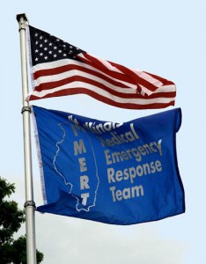
Chair
George Beranek, MD, MBA, FACEP

Treasurer
Dave Wold, DDS

Secretary
Lisa Wax, RN, BSN

Members
Bernard Heilicser, DO, MS, FACEP, FACOP
Marge Luczak, RN, MSN

Director, non-voting
Mary Connelly, RN, BSN
maryc@imert.org

President, non-voting
Moses Lee, MD, FACEP, FAAEM
mosesl@imert.org

The IMERT Board of Directors holds meetings on a quarterly basis. Meetings were held on the following dates during the grant cycle:

- October 5th, 2017
- December 14, 2017
- March 18, 2018
- June 21, 2018

MEDICAL DIRECTOR AND BOARD PRESIDENT

Dr. Moses Lee is a Board Certified Emergency Medicine Physician who has over 25 years of experience working in the field. Dr. Lee has served as the Medical Director since its inception in 1999 and as such has over 15 years of experience responding to disaster events, leading and training volunteers, and coordinating and presenting on a variety of disaster preparedness and response, CBRNE, and mission support related subjects.
Dr. Lee provides oversight and direction of the IMERT Program staff and volunteers, and ensures deployment readiness capabilities. Dr. Lee directs our education and training programs, attends training and participates in exercises.

He also serves as a subject matter expert on the following committees
- EMSC Pediatric Preparedness
- Illinois Terrorism Task Force
- Crisis Standards of Care Core Committee
- Public Health ITTF subcommittee
- Regional Healthcare Coalition –HPP
- FEMA Region 5 Risk Committee
- Dr. Lee is advising on the further development of a Pediatric Care Medical Specialist Team in cooperation with EMSC.

Dr. Lee provides oversight to the program as the non-voting President of IMERT’s Board of Directors.

PROGRAM OVERVIEW

As a past beneficiary of the Hospital Preparedness Grant Program, IMERT has responded to numerous emergencies, disasters, and high risk/high profile events around Illinois as well as out of state. The most recent large scale event was in Southern Illinois during the Eclipse in August 2017. We worked to assist the regional healthcare coalition in planning for medical care for the thousands of attendees that inundated the community. This unique event provided the opportunity for IMERT to combine resources with the Region 5 Shawnee Preparedness and Response Coalition (SPARC) and the Region 2 Peoria Regional Medical Emergency Response Team (RMERT). This blend of medical assets brought substantial medical resources and capabilities to the region. IMERT worked with these and other agencies to develop a plan and implement strategies for both routine and catastrophic medical needs situations.
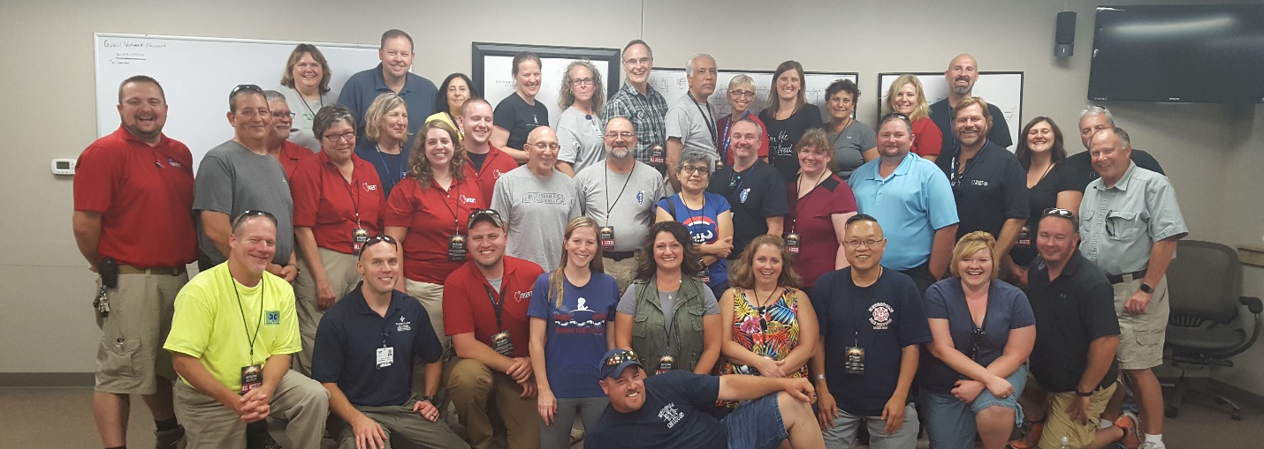
Eclipse Medical Team: IMERT, Region 2 RMERT, Region 5 Healthcare Coalition
IMERT has cultivated partnerships within the health care community and with numerous agencies involved in local, regional, state, and national preparedness and response. This includes participation in planning, implementation, and evaluation of exercises for hospitals, local communities, regional entities and other agencies. These efforts directly and positively impact capability in communities to support the unique medical needs caused by disaster for both responders and survivors. IMERT works and trains with state agencies and community partners including: Illinois State Police, CERT, MRCs, Hospitals, the State Weapons of Mass Destruction Team, and the IEMA Radiological Assessment Field Team. These “real-time” trainings specifically focus on the medical needs of responders and focus on prevention of problems as well as early intervention to mitigate health issues in the community.
Physicians and staff provide education and training for health care providers and community groups within the state. An addition this year included providing the

American College of Surgeons STOP the BLEED courses. The aim of this course is to teach the community how to recognize life threatening bleeding and how to intervene. IMERT members who are eligible to become instructors attend the train-the-trainer course. We also provide classes for the community in general. So far this year over 150 people have completed this training. Other trainings that we provide include; NIMS/ICS, and presentations to various community organizations on medical team capabilities. Senior leadership staff has first-hand experience in response to catastrophic incidents and are capable of providing planning insights and logistics support to state agencies and Illinois communities.
IMERT promotes volunteerism throughout the state. Many team members have reported the training and experiences they receive from IMERT enhance their work in the healthcare sector and in many cases has resulted in their participation in both hospital and community emergency preparedness activities.

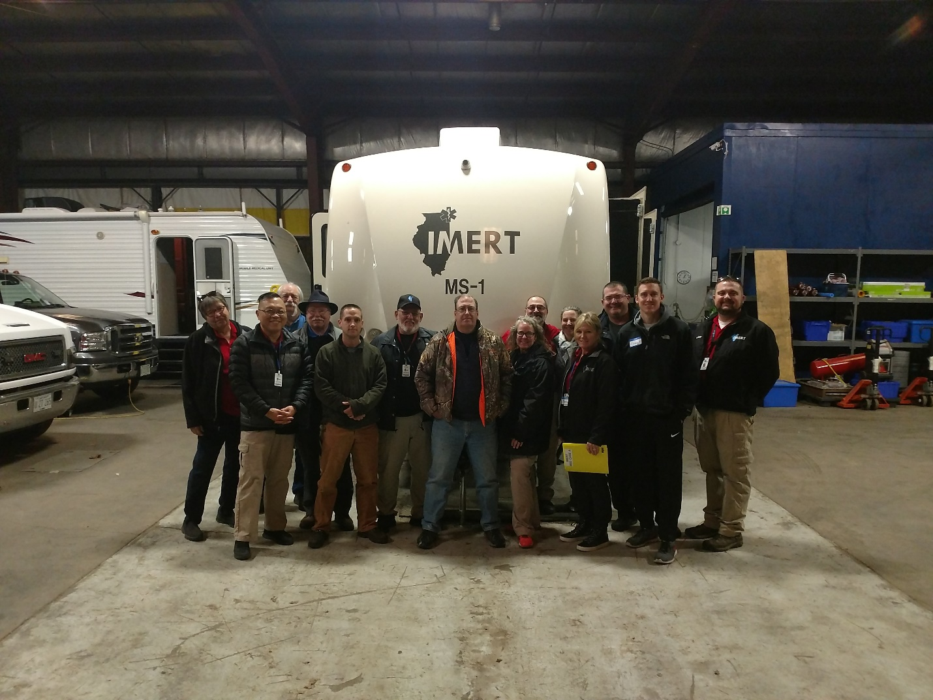
IMERT Team members gather after a day of training on IMERT operations and equipment

SIGNIFICANT ACTIVITIES OF 2017 AND 2018

- Provided 13 Deployment Operations Courses at locations around the state for new and current IMERT members to receive face-to-face training on IMERT operations and its role in the state disaster plan. Spring and summer sessions all included Stop the Bleed Training and some included moulage training.
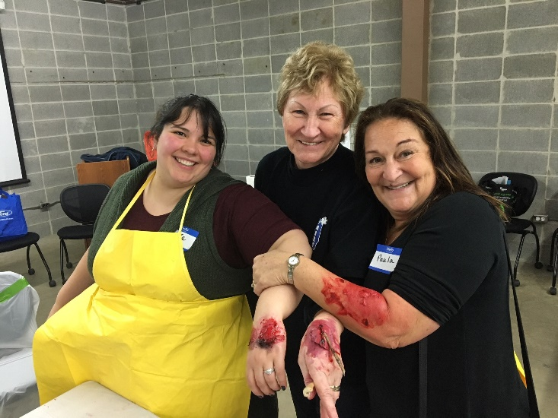 | Members show off their new skills after attending the Moulage application training session at one of the Deployment Operations Courses

- Conducted an in person training with members of the Pediatric Care Medical Specialist Team. This team is meant to provide pediatric expertise as consultants during a disaster that involves multiple pediatric patients. This team does not deploy as boots on the ground, but is instead available via phone or video conference.
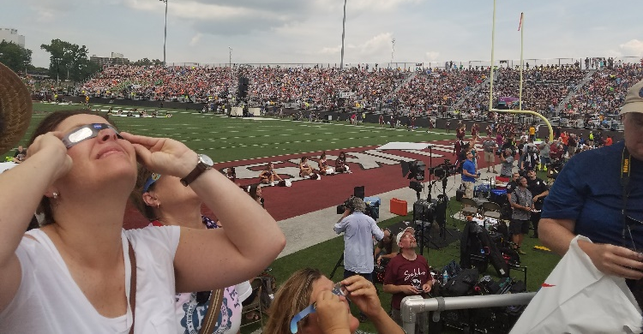
- Participated in planning and response for the Eclipse Event in Carbondale on August 21st. This included partnering with Region 5 Healthcare Coalition and Region 2 RMERT in a live training by combining resources to provide First Aid capability on the campus of SIU on Eclipse day.
- Participated with IDPH at the IEMA Earthquake Planning Course of Action Workshop and the Earthquake Recovery Workshop.
- Collaborated with IDPH Planning on updating the ESF-8 plan regarding Alternate Care Sites and Temporary Medical Treatment Sites.
- Collaborated with local EMA, EMS, IDNR and law enforcement in Massac County to enhance planning for medical resource availability during a large community event at Fort Massac State Park. This event usually attracts over 100,000 attendees. IMERT members joined healthcare providers from the Carbondale Regional Healthcare Coalition and Metropolis EMS for an immersion training for medical support at the event while simultaneously addressing strategies and tactics in the event of a mass casualty.
- Ultrasound. This technology is already being used for emergency care around the world. Having point-of-care ultrasound available will be a great advantage, helping us to diagnose and treat patients in complicated circumstances. Dr. Moses Lee attended three trainings this cycle to further this project’s development.
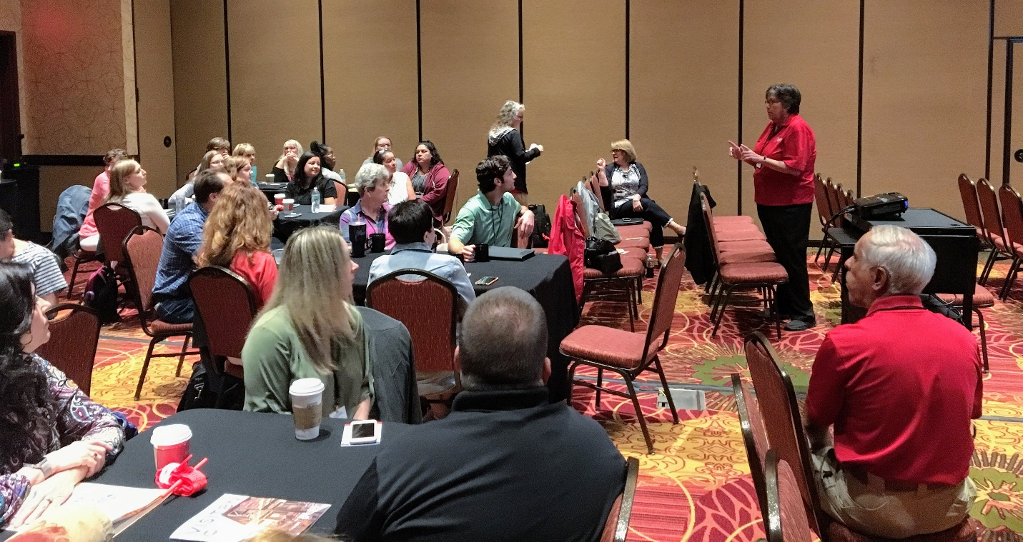
- STOP the BLEED Instructor trainings. In response to community and volunteer requests, IMERT staff trained to begin providing the STOP the BLEED training. Staff attended a train- the- trainer session from the American College of Surgeons in February 2018. The curriculum was integrated into IMERT specific trainings as well as provided to the public upon request and as resources allowed. These included presentations at the Illinois Department of Public Health conference and senior nursing students at North Park University.
IMERT presentation of STOP the Bleed to attendees at the IDPH Conference in Springfield in June.

- The Medical Director and Executive Director met with the ITTF Chair to discuss catastrophic medical surge planning.
- IMERT performed communications exercises with its membership in February and June. Both of these exercises utilized the IDPH SIREN system to send messaging and collect responses.

PARTNERSHIPS

Since its inception, IMERT has cultivated and fostered partnerships within the health care community and preparedness organizations. IMERT assists regional healthcare coalitions, local public health entities, and other response agencies with disaster response planning and training, as requested.
The Team’s leadership participates in all Regional Hospital Coordinating Centers (RHCC) meetings. Additional partnerships include:
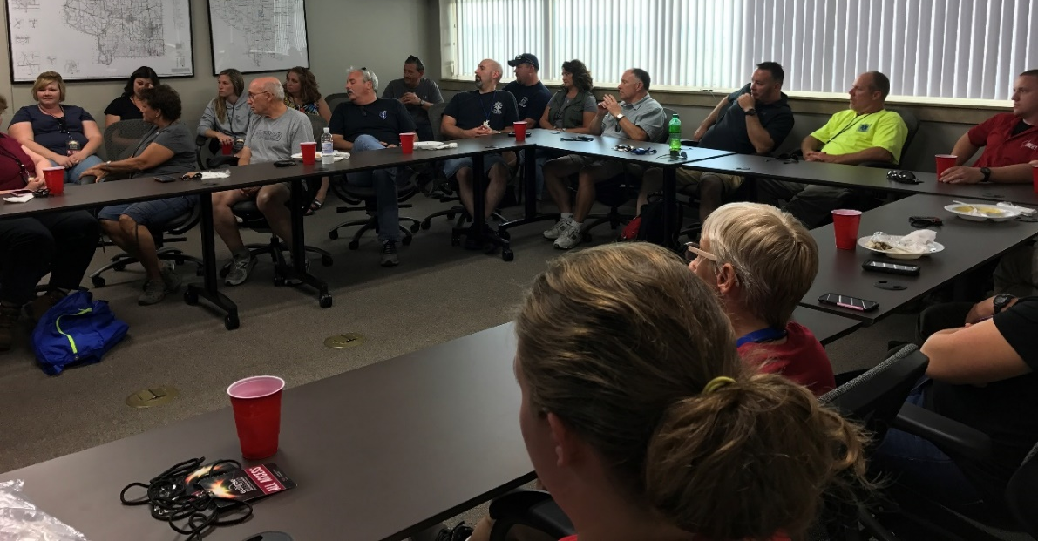

- Carle Hospital of Champaign Illinois
- Chicago Fire Department
- Emergency Medical Services for Children
- Illinois Emergency Management Agency
- Illinois Department of Public Health
- Illinois Law Enforcement Alarm System
- Illinois Medical District Hospital Preparedness Coalition
- Illinois Medical Reserve Corps
- Illinois Air National Guard
- Illinois Primary Healthcare Association

- Illinois State Police
- Illinois Terrorism Task Force
- Illinois Urban Search & Rescue Teams
- John H. Stroger Hospital of Cook County, SIM-Lab
- Medical Reserve Corps of Illinois
- Regional Hospital Coordinating Centers
- SWMDT (State Weapons of Mass Destruction Team)
- Urban Search and Rescue Teams

COLLABORATIONS

IMERT maintains a partnership MOU agreement with the Illinois Incident Management Team(IMT), which allows the group to act as a state asset, to respond to major incidents and natural disasters throughout the State of Illinois and other locations within the United States. The Incident Management Team provides management “assistance” to local jurisdictions at times when local resources may be over-taxed due to the nature or significance of the incident.

IMERT continues to collaborate with the Emergency Medical Services for Children (EMSC) on pediatric preparedness planning and pediatric team development.
The Pediatric Care Medical Specialists (PCMS) is a specialty group within IMERT. It is a group of Physicians and APNs who provide medical/nursing expertise to non-pediatric hospitals throughout the state that may need to care for children over an extended amount of time. This team is meant to provide pediatric expertise as consultants during a disaster that involves multiple pediatric patients. This team does not deploy as boots on the ground, but instead will be available via phone or video conference.
- An in-person training with members of the IMERT Pediatric Care Medical Specialist Team was conducted.
- A communications exercise of the team members was conducted.

COMMITTEE MEMBERSHIP

IMERT staff and senior leadership participate on a number of committees both in Illinois, other states and at the federal level.

- ITTF/IDPH Public Health and Medical Sub- Committee, Illinois Department of Public Health
Representative: Mary Connelly, BSN, Rick Steel EMT-P

- Illinois Terrorism Task Force
Representative: Dr. Moses Lee, Mary Connelly, BSN, Chris Jansen Chief Planning-Logistics

- Strategic Technology Reserve Group, Law Enforcement Mutual Aid Committee, ITTF
Representative: Christopher Jansen
Multi-agency group of representatives from across the state that have communications assets and aligns its work products according to the SAFECOM Interoperability Continuum.
- Crisis Standards of Care Core Work Group
Representative: Dr. Moses Lee, Mary Connelly, BSN

- Crisis Standards of Care – EMS Subcommittee
Representative: Mary Connelly, BSN

- State Terrorism Intelligence Center Emergency Services Webinar and Briefings
Representative: Christopher Jansen

Hospital Preparedness Program
Representative: Moses Lee, MD and Mary Connelly, RN
As the source of federal funding that supports regional health care system preparedness, HPP promotes a sustained national focus to improve patient outcomes, minimize the need for supplemental state and federal resources during emergencies, and enable rapid recovery.

In cooperation with the above committees and the Illinois Department of Public Health, IMERT works to sustain and build the continuity of health care services delivery and a medical surge.

RESPONSE CAPABILITIES

VOLUNTEER STATUS

IMERT maintains a roster of credentialed and trained volunteers located throughout the State of Illinois, with 150 of these who are current in meeting the deployment qualification requirements. Qualification includes: back ground check, valid licensure (for those conducting medical care) completion of NIMS100,200 and 700 as well as attendance at an annual Deployment Operations training. Attendance records are kept at the IMERT office.

Thirteen Deployment Operations Courses were provided during FY2018 at locations around the state for new and current IMERT members to receive face-to-face training on IMERT operations and its role in the state disaster plan. Spring and summer sessions all included Stop the Bleed Instructor Training and some included moulage training. IMERT provided volunteers with mileage reimbursement at current state approved rates when participating in exercises. IMERT also provided lodging for team members attending trainings when needed.

RECRUITMENT AND RETENTION

IMERT recruited and credentialed 20 new members this grant cycle. Members who successfully complete the application process have had their credential information verified and have undergone a background check screening. They have also completed the state and federally required ICS 100 and 200 and NIMS 700 courses.
IMERT utilizes a variety of forums to promote itself and recruit volunteers for the team. These include word of mouth, recruitment exhibits, marketing and promotional materials, website, social media, and advertisement.
IMERT utilizes its webpage at www.imert.org to recruit and inform. The pages allow messages to be posted both to the public, and to team members only in the secure password protected Team Member’s section. The Team Members Section features a front announcement page, information on policy and procedure, and activities, and allows members to download important forms. A section of the webpage on Disaster Preparedness helps improve awareness and empower responders and citizens with knowledge about what they can do to be ready.
To keep volunteers connected to IMERT, news briefs are emailed on a quarterly basis. Topics include summaries of activities, information on upcoming events, policy notification, and information on education and volunteer opportunities, among others. IMERT also leverages the Facebook, Twitter and Pinterest platforms to promote the program and encourage community preparedness.
Additional program promotion takes place at professional conferences around the state. IMERT attends a number of conferences and exhibits to recruit new members and raise awareness on the role health care workers can play in preparing their communities for disaster. During this grant period IMERT participated in multiple recruitment events.
9/5-7/2017 IEMA Conference Springfield, IL
9/15/17 Region 7 Conference Tinley Park, IL
11/7/2017 Community Outreach Presentation North Park University, North Park, IL
4/12/2018 Community Outreach Presentation UIC School of Public Health, Chicago
4/20/2018 ENA Conference Oak Brook Terrace, IL
5/23/18 CFD EMS Day Chicago, IL
3/5-6/18 ILEAS Conference Springfield, IL
6/11-14/18 IDPH Conference Bloomington, IL

COMMUNITY OUTREACH

Dr. Moses Lee, Medical Director and Team Commander, and Mary Connelly, IMERT’s Director, frequently give presentations on behalf of IMERT and IDPH. In addition to presenting on IMERT and its role in the state disaster plan, topics have included NIMS and HICS training as well as emergency preparedness, and treating CBRNE casualties These events are listed below.
7/25/17 CBRNE Course Stroger Hospital, Chicago, IL
10/25/17 CBRNE Course Stroger Hospital, Chicago, IL
11/7/2017 Community Outreach Presentation North Park University, North Park, IL
4/12/2018 Community Outreach Presentation UIC School of Public Health, Chicago

MEDICAL TEAM

The medical team is comprised of healthcare providers from across the patient care spectrum. IMERT team members include physicians, nurses, paramedics, medics, PAs and Advanced Practice Nurses, pharmacists, dentists and more. The largest percentage of IMERT volunteers are registered nurses. This large nursing population allows IMERT operational sustainability during extended deployments.

Med Team is from multiple disciplines and backgrounds

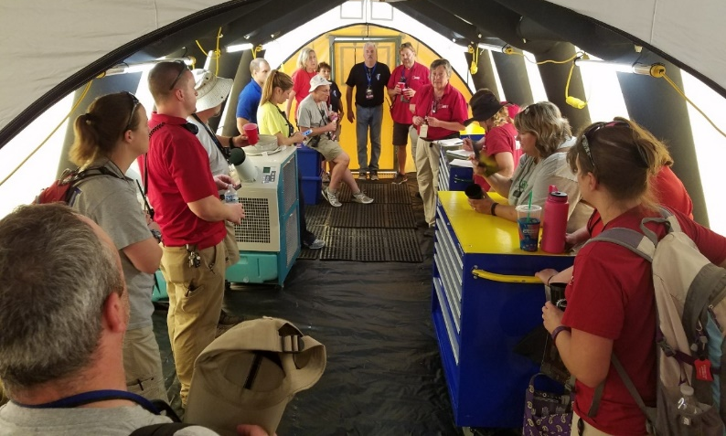
IMERT members primarily work in emergency medicine and critical care environments. Volunteers have disaster experience from
their volunteer hours with IMERT and their work settings; hospitals, pre-hospital and/or military. This combination of pre-hospital and emergency trained clinicians backed up by a skilled and talented mission support team provides the State of Illinois with an exceptional medical resource for emergency situations.
There are 150 members eligible for deployment.

MISSION SUPPORT TEAM

A crucial piece for readiness and response is the logistics component. These team members support the medical mission by managing logistics, communications, planning and other needs. Within a medical care setting support services are critical to providing quality medical care, ensuring that supplies are available when needed, that the environment is clean, that equipment is functioning and that staff and patients have what they need.
When IMERT is assigned to provide medical coverage at trainings or is deployed, a minimum amount of medical and patient equipment is required and skilled responder support is needed to distribute and maintain these supplies.
IMERT’s Mission Support Team is comprised of volunteers mostly from the private sector with special skill sets such as information technology, communications, HAM radio operators, materials management, scene safety, and resource management. This support element is an important link to the non-medical private sector community.
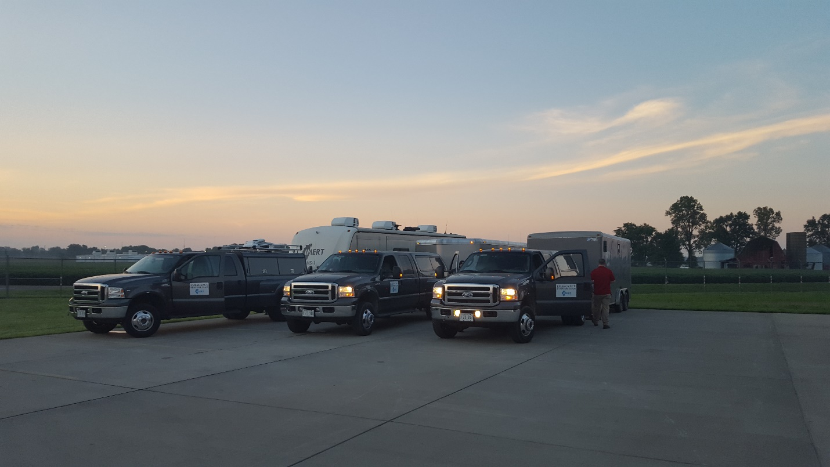

DEPLOYMENT RESPONSE PACKAGES

IMERT is capable of a flexible, scalable medical response. The initial medical assessment team roll-out can be accomplished in 24 hours. Additional pre-credentialed and trained responders from a variety of clinical backgrounds are then requested as needed. These providers will assist local medical providers with extended medical care and stabilization at a casualty collection or alternate medical treatment site. The IMERT organization’s response capabilities provide increased mitigation potential and increased medical surge response capacity within the State.
FLEXIBLE and SCALABLE

Strike Team: IMERT Medical Needs Assessment
Purpose: Ascertain scope of medical needs at a disaster scene, casualty collection site or alternate medical treatment site
Team: 4-5 with access to an IMERT physician by phone/text/radio
Composition: 5: (1) IMERT Command Staff (1) physician if available (2) Nurse, (1) EMT P/B (1) Logistics/Communication
Arrival Time Frame Up to 24 hours, dependent on travel conditions and location of incident
Equipment: (1) response truck, (1) trailer with gator {optional}, strike team medical supply response package. Basic team support supplies
Limitations: Cannot travel emergently, carry minimal medical equipment for immediate use
Capabilities: Can be self-sufficient for 72 hrs. Can assist local healthcare providers with emergent situational planning and can evaluate existing structures for suitability for utilization as a TMTS (Temporary Medical Treatment Station)
Strike Team: IMERT Primary Medical Response Team
Purpose: Assist local medical providers with initial medical stabilization; assist with set up of temporary medical treatment site
Team: 8-15 IMERT, physician on site or available by phone/radio
Composition: (2-3) IMERT staff including Director or Chief Nurse. 4-5 RNs, 2-5 EMS providers, 2-4 logistics/communications

Arrival Time Frame: 24-48 hours, dependent on travel conditions and location of incident
Equipment: (2-3) response trucks, (2-3) trailers, 50 patient response package, 15 team member support package
Limitations: equipment and transport vehicles need to be retrieved from Urbana, personnel will need to stage at ILEAS or other secure location, fully loaded trailers travel slow, difficult to maneuver in high wind situation, may require security assistance, may need lodging or sleeping quarters assistance
Capabilities: can be self-sufficient for 72 hours, can integrate with local medical responders to provide emergency medical care, supply package can support approximately 50 patients of various acuity levels for 24-48 hours. Can be adjunct medical staff to local healthcare providers for 72-96 hours
Task Force: IMERT Task Force
Purpose: Assist local medical providers with extended medical care and stabilization at a casualty collection or alternate medical treatment site. TF meant to supplement IMERT Primary Response Team already on site. If not on site, IMERT command staff will accompany Task Force
Team: 20-25, (1-2 physician/p.a./nurse practitioners)
Composition: Team Commander, Director, CNO, Logistics Chief, 2-3 Charge RN, 8-10 RN (both ER and other specialty) 6-8 EMT P/B, 3-5 admin
Arrival Time Frame: 24-48 hour, dependent on travel conditions and location of incident
Equipment: 5-6 response trucks, 5-6 response trailers, ACS equipment package, 25 team support package, additional medical supplies if indicated (immunizations, IV fluids, etc.)
Limitations: Will need all response vehicles or other agency assist with transport of personnel, will need assistance to obtain any additional medical supplies appropriate for incident, will require security, fully loaded trailers travel slow, will require sleeping quarters and may need food and water support after 72 hours
Capabilities: can provide medical coverage for a 50 bed treatment site in an austere environment for 96 hours can be an adjunct to local medical for larger patient load, can be self-sufficient for 72-96 hours

ALTERNATE CARE SYSTEMS

An important piece of IMERT’s mission is the development of a Strategic Plan for the implementation of Alternate Care Systems in Illinois. To further this goal, IMERT regularly participates in meetings on the topic of Alternate Care Systems

IMERT will continue to research and develop Alternate Care Site Operations strategies and tactics. IMERT will update internal Mass Casualty Triage training.
An Operations Guide on how to set up and operate an Alternate Care Site is available on line at the IMERT website by going to www.imert.org and scrolling to the bottom to click on Alternate Care Site (ACS) Planning or at either of the sites below: www.alternatecaresiteplanning.com or www.temporarymedicaltreatmentstationplanning.com.
A meeting on this topic was held with the IMERT Executive Director and the IDPH OPR Chief of Staff as a status briefing. Currently there are no specific deliverables requiring HCCs to address ACS planning though there have been some informal discussion with a few of them.
- Conducted an in-person training with members of the Pediatric Care Medical Specialist Team. This team is meant to provide pediatric expertise as consultants during a disaster that involves multiple pediatric patients.
- Participated with IDPH at the IEMA Earthquake Planning Course of Action Workshop and the Earthquake Recovery Workshop.
- Collaborated with IDPH Planning on updating the ESF-8 plan regarding Alternate Care Sites and Temporary Medical Treatment Sites.

TEAM TRAINING

Exercises and trainings developed by IMERT are conducted according to HSEEP protocols. Our organizers and planners have all completed HSEEP training as offered through IEMA.
NIMS compliance is achieved through NIMS implementation in all incident action plans, training exercises, and deployments. Examples include employing the Incident Command system during drills and events and ensuring all participating personnel have completed the ICS 100, 200, and 700 training courses. IMERT has received recognition from FEMA’s National Integration Center acknowledging IMERT’s dedication in support of NIMS’s implementation.
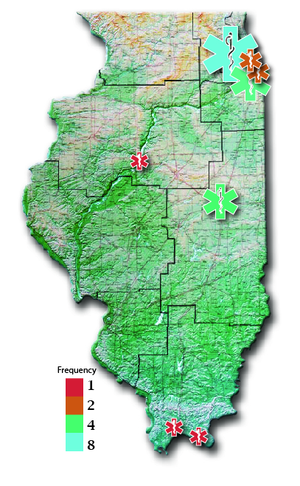
IMERT Training map for 2018 showing training locations and frequency
DEPLOYMENT OPERATIONS COURSE

The Deployment Operations Course is an orientation and training program for all new and current members that outlines staff and volunteer requirements for training, exercises, and deployment. This training is available online for just-in-time review as well.

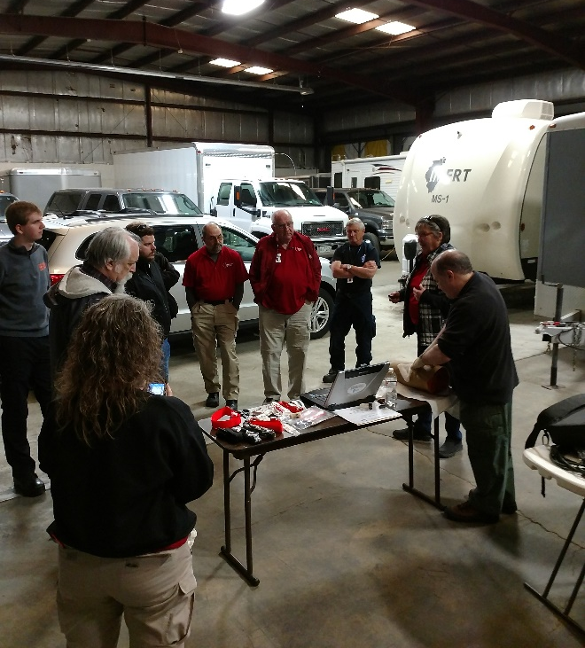
IMERT has contracted with experienced staff to design, implement and evaluate these trainings. The curriculum for this program is updated annually, which took place in September of 2017. The first half (Part I) of this course is an introduction to IMERT policies and procedures and equipment training. It covers the Illinois State Disaster Plan and response, available state resources, basic Incident Command System (ICS) information, triage and treatment protocols, and the issues unique to field response. The training is a team building exercise and orientation to IMERT equipment and alternate care site role. This is a required session before applicants are allowed to participate in real-world training sessions or deployments.

The second half of the course covered rotating topics to develop volunteers’ knowledge. Topics included telemedicine in a disaster setting, the Stop the Bleed curriculum, and Moulage Application.

13 sessions of the Deployment Operations Course were conducted this budget period.
7/14/17 14 participants ILEAS, Urbana
8/4/17 31 participants NIPSTA, Glenview
9/8/17 11 participants CCHS, Oak Forest
9/9/17 16 participants CCHS, Oak Forest
11/10/2017 15 participants ILEAS, Urbana
11/11/17 10 participants ILEAS, Urbana
3/30/2018 10 participants ILEAS, Urbana
4/5/2018 13 participants Oak Forest
4/13/2018 16 participants NIPSTA, Glenview
4/14/2018 14 participants NIPSTA, Glenview
5/10/2018 16 participants NIPSTA, Glenview
5/11/18 16 participants NIPSTA, Glenview
6/4/18 14 participants CCHS, Oak Forest

IMERT’s Participant Evaluations from this course received overwhelmingly positive feedback. Some sample comments include:

- Great job. Moulage and stop the bleed. Awesome
- Lots of good review—love hands on
- Learned more about Moulage – very interesting
- Barb did great job with stop the bleed/bleeding control. John and Marge did a great job with Moulage
- Having used the Israeli bandage only in training, helpful to hear. The Doctor showing effective alternate procedure. Enjoyed Moulage with Marge and John
- Tourniquet application, stop the bleed – great class
- IMERT set-up goals, etc. stop the bleed
- I loved learning about the different types of tourniquets and hands on practice
Participants have asked for the course to expand on the following topics. A majority of the requests are for more hands-on trainings. These concepts will be considered for expansion during course review in the next grant cycle.

- More information on what exactly a deployment looks like/consists of would be good
- Logistics of volunteering
- May be interesting to hear debrief/feedback on prior training/deployment (eclipse)
- More equipment review – START Triage, etc.
- Real life simulations
- I would like an opportunity to experience an actual field deployment or to help with a planning field activity. Classroom is good but actual experience is really needed for preparedness for a field deployment/emergency
- Nice course. Add some outside exercises. Great group of people!! Thanks
- I enjoy anything hands on

MOULAGE

Including moulaged victims as an element of a multi-casualty exercise substantially adds to realism and provides responders with opportunities to react to patient injuries. While many agree that moulage is a great enhancement for training, there are very few resources for exercise planners to learn Moulage techniques. Realizing this was a gap we could address, IMERT developed a moulage team and training program. The program was developed by drawing from some of IMERT’s experienced volunteers.
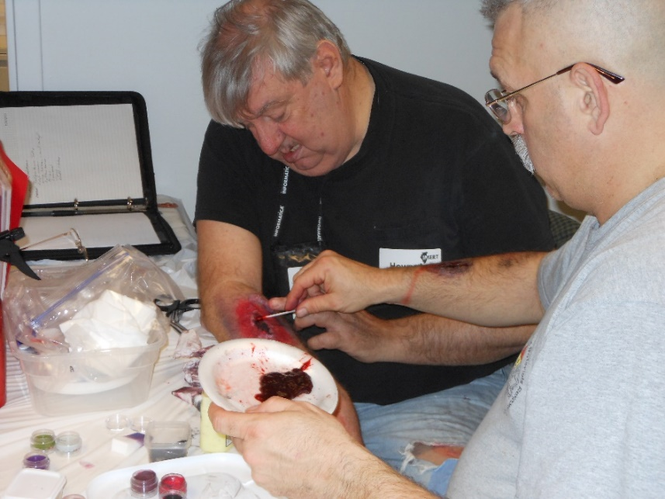
From these sessions, held this grant year and during past years, IMERT has developed a moulage team that has participated in exercises at various venues around the state. Scenarios varied from community focused mass casualty incidents to active shooter drills. Some partners we have collaborated with in the past include fire departments, hospitals, local emergency management, CERT, and the Illinois National Guard.

STOP THE BLEED

The Stop the Bleed program was begun as a part of an American College of Surgeons initiative to assist our national preparedness utilizing the premise that anyone at the scene of an emergency can act as an immediate responder to save a life if they know what to do. This program focuses on bleeding control techniques including using hands, dressings, and tourniquets. The goal is for many of our members to become instructors and be able to bring this course back to their own communities. More information about this program is available at https://www.bleedingcontrol.org/.

Staff and team members attended the American College of Surgeons Instructor Class in Chicago in February 2018. During this quarter IMERT staff conducted multiple STOP the Bleed courses for healthcare providers and members of the
public. This included 6 train the trainer sessions for team members attended by 90 participants.

Additionally, a training session was presented at:
- The IDPH Preparedness Conference attended by 40 participants
- The School of Nursing Seniors at North Park University in Chicago, attended 24 participants.

STAFF AND TRAINING TEAM

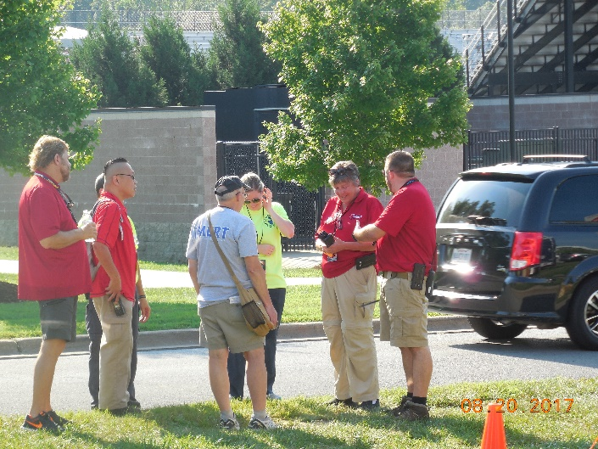
IMERT engaged the following part-time contractors to address specific tasks. These individuals have the expertise and skills necessary to complete their contracted obligations through their experiences in their workplace and as IMERT volunteers.
Barbara Oliff, RN, BSN
Tracy Brookshire, RDH, BSDH
Rick Steel, EMT-P
Chris Niziolek, EMT-P
Amy Mathes, RN, EMT-P, PhD

Some of the tasks completed were:
- Administrative assistance, including technical support
- Training development and instruction

- Community training development and implementation
- Standard operating guideline development and review
- Inventory standardization and maintenance
- Community exercise development and evaluation
- Committee participation

The IMERT’s employees include the following individuals:

Executive Director: Mary Connelly, RN, BSN, NHDP (full-time)
Grant Administrator: Elizabeth Lee, MS (part-time)

Christopher Jansen is Chief of Planning and Logistics. His position is supported through a separate grant provided by the Illinois Terrorism Task Force (ITTF) and managed by the Illinois Law Enforcement Alarm System.
All staff have completed NIMS training including ICS 100, 200, 700, 250, 703, 800, 808. IMERT’s employees and some of the contracted staff members have also completed ICS 702 and 704 as well as ICS 300 and 400 Command courses. Staff have also completed HSEEP training.

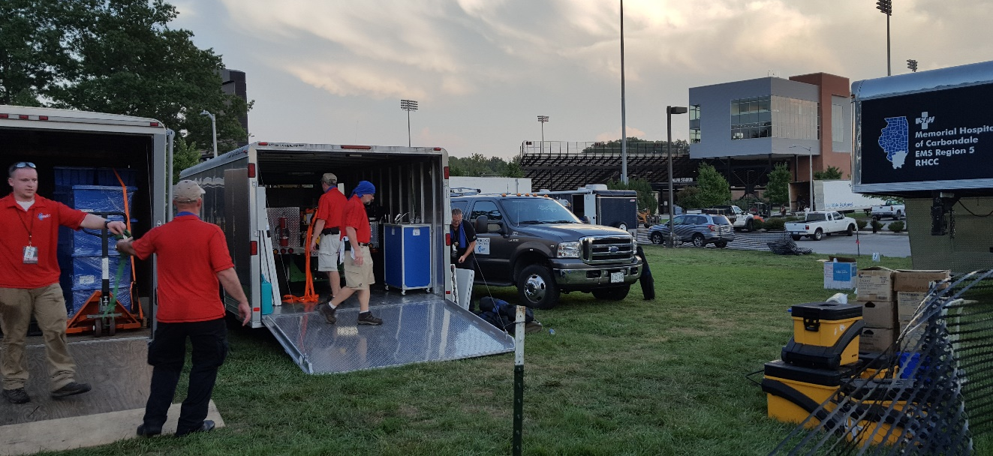
SIU Med Team IMERT-Region 5 Coalition -Region 2 Coalition

ADDITIONAL TRAINING AND
DEVELOPMENT

Staff and volunteers participated in multiple trainings and development events throughout the grant cycle. These trainings serve to advance interagency participation and hone staff and volunteer capabilities. Records of all training activities and participation are maintained by the staff and are available upon request. HSEEP formatted After Action Reports for IMERT sponsored exercises have been submitted to the HPP Coordinator.

- 7/25/17 CBRNE Course Stroger Hospital, Chicago
- 8/3/17 Disaster Trauma Preparedness, Oak Brook Terrace
- 8/29/2017 Communications drill, Alert and response checking availability
- 8/20-21/17 Eclipse Deployment Event Medical Support, Carbondale
- 9/25-27/17 FEMA Earthquake Response and Recovery Workshop IEMA
- 9/25/17 PCMS Team Training (Pediatric Team) NIPSTA, Glenview
- 10/20-22/17 Fort Massac Reenactment, Metropolis
- 10/25/17 CBRNE Course Stroger Hospital, Chicago
- 11/30/17 EMAC Mission Ready Package Training IEMA, Springfield
- 1/30-31/18 IDPH/OPR/RHCC Strategic Planning Workshop Springfield
- 2/9/18 Communications Exercise
- 2/9/2018 StarCom Radio Exercise
- 2/27/2018 Weather Watcher Tabletop Exercise Cook County
- 4/25/18 Ultrasound Training Chicago
- 5/3/18 Strategic Technology Reserve functional exercise Urbana,
- 5/15/2018 Stroger Hospital and City-wide EX "Highly Contagious Outbreak”
- 6/20/2018 IMERT Communications Exercise
OPERATION SOUTHERN SKY, ECLIPSE MUTUAL TRAINING

On August 21, 2017 most of the state experienced a solar eclipse, with southern Illinois in line with the path of totality. Thousands of people flocked to the Carbondale area. In preparation for the crowd, emergency management and healthcare providers initiated a massive interagency planning effort. At the request of Region 5 RHCC, IMERT participated in the planning and response for Operation Southern Sky. This included a live training by combining resources to provide First Aid capability on the campus of SIU on Eclipse day. Many useful lessons learned came from this training.

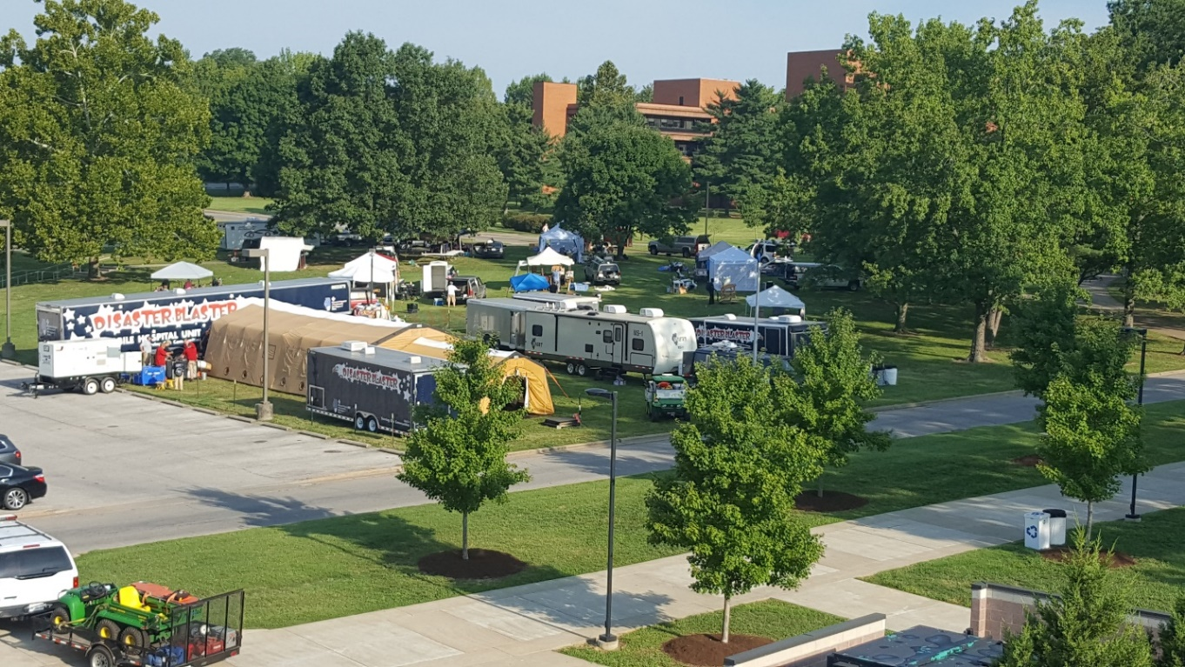
Healthcare Coalition and IMERT alternate care site set-up on the SIU campus

- Participated in multiple teleconferences with multiple agencies regarding coordination of medical resources and response.
- Planning meetings included 3 in-person multiagency meeting in Carbondale with local first responders. Additional in-person meetings were with: SIU Public Safety and Eclipse Steering Committee, Campus Student Health, Region 2 RMERT, Region 5 HCC, Region 4 HCC, Department of Natural Resources, IDPH, and IEMA
- Participated in a multi-agency call with the Director of IEMA on Eclipse event readiness on 8/1/2017
- A debriefing meeting was held with IDPH on 8/24

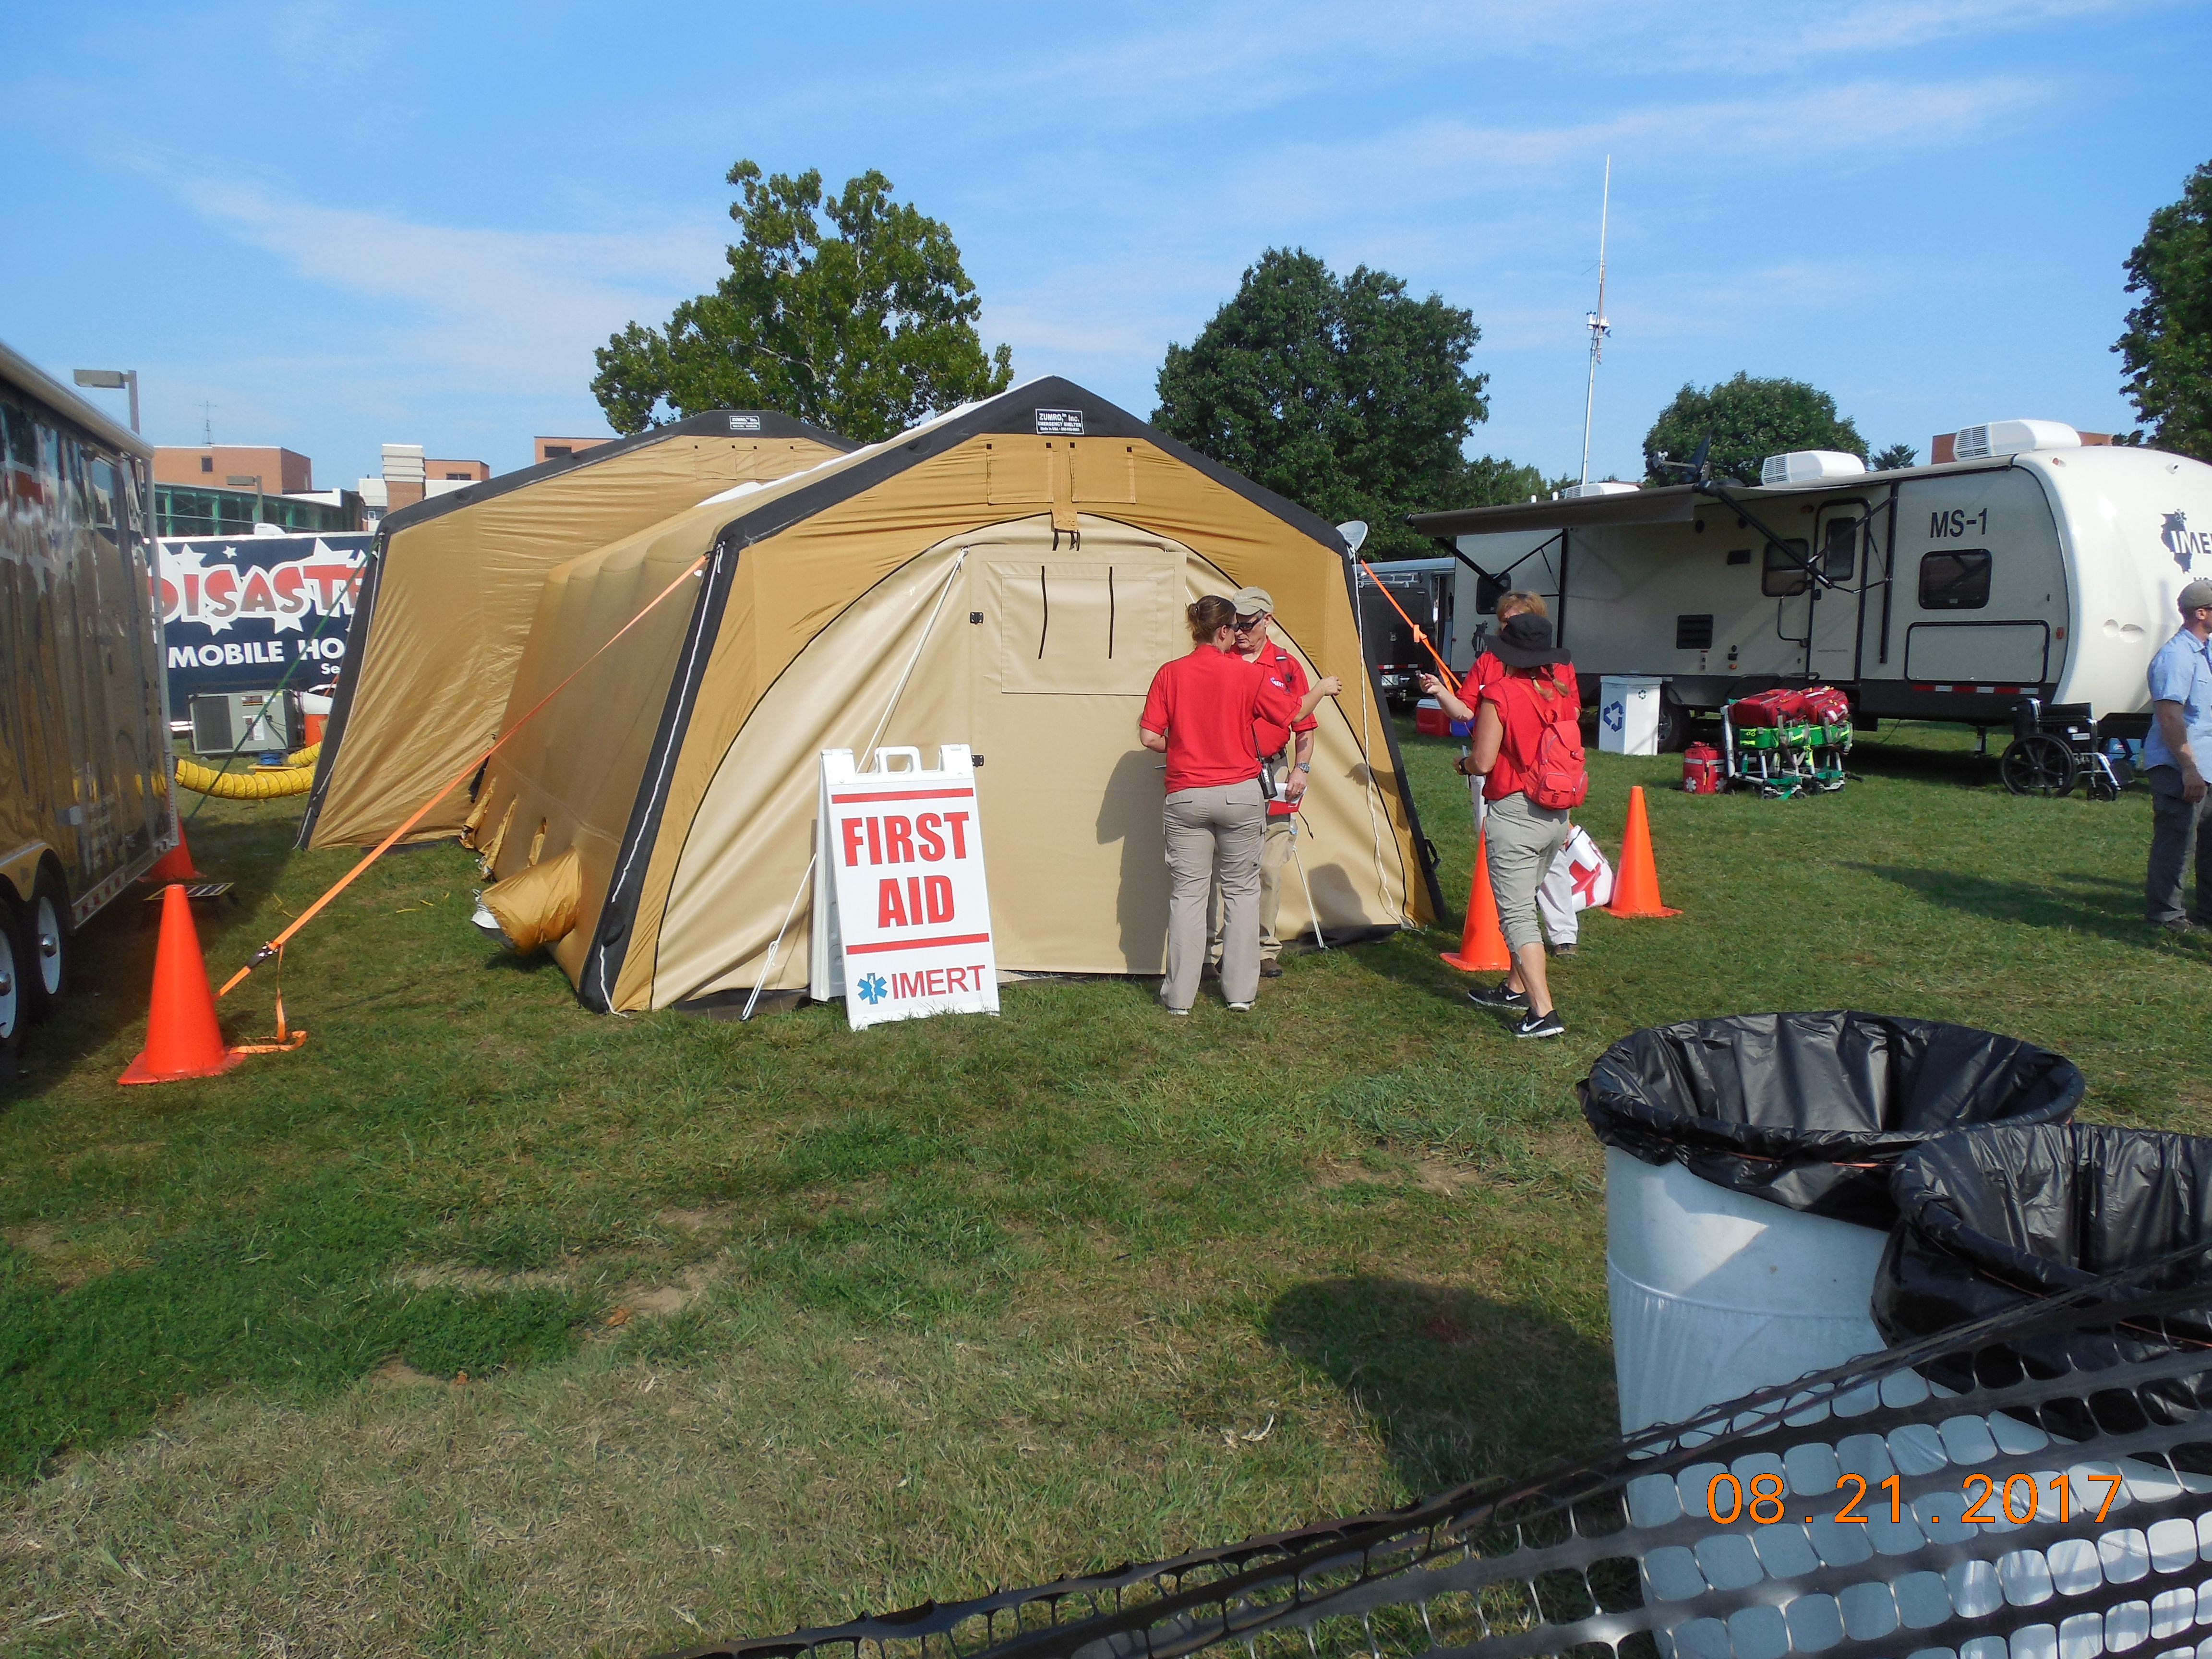
MEDICAL COMPOUND at SIU for the eclipse

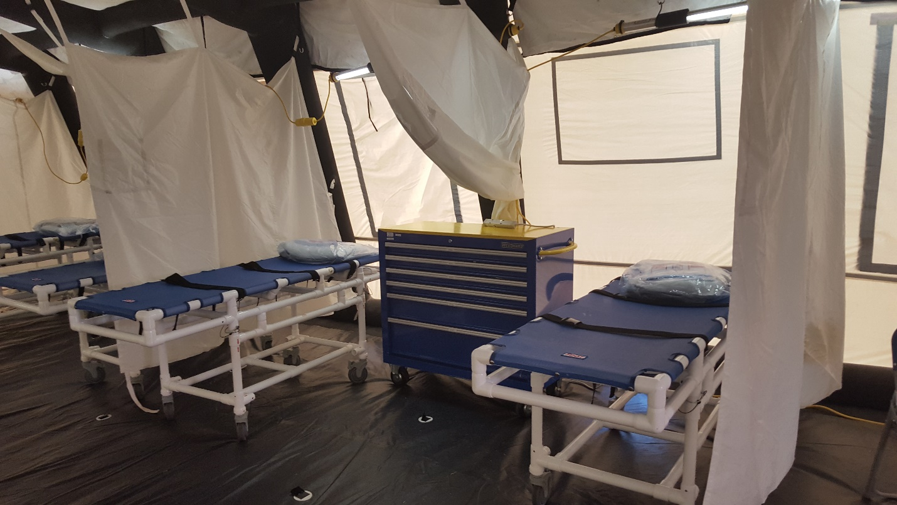
Clinical Care Set-up –Eclipse Southern Illinois University

MASSAC COUNTY EXERCISE

IMERT collaborated with local EMA, EMS, IDNR and law enforcement in Massac County to enhance planning for medical resource availability during a large community event at Fort Massac State Park. This event usually attracts over 100,000 attendees.

IMERT members joined healthcare providers from the Carbondale area Regional Healthcare Coalition and Metropolis EMS for an immersion training for medical support at the event while simultaneously addressing strategies and tactics in the event of a mass casualty.

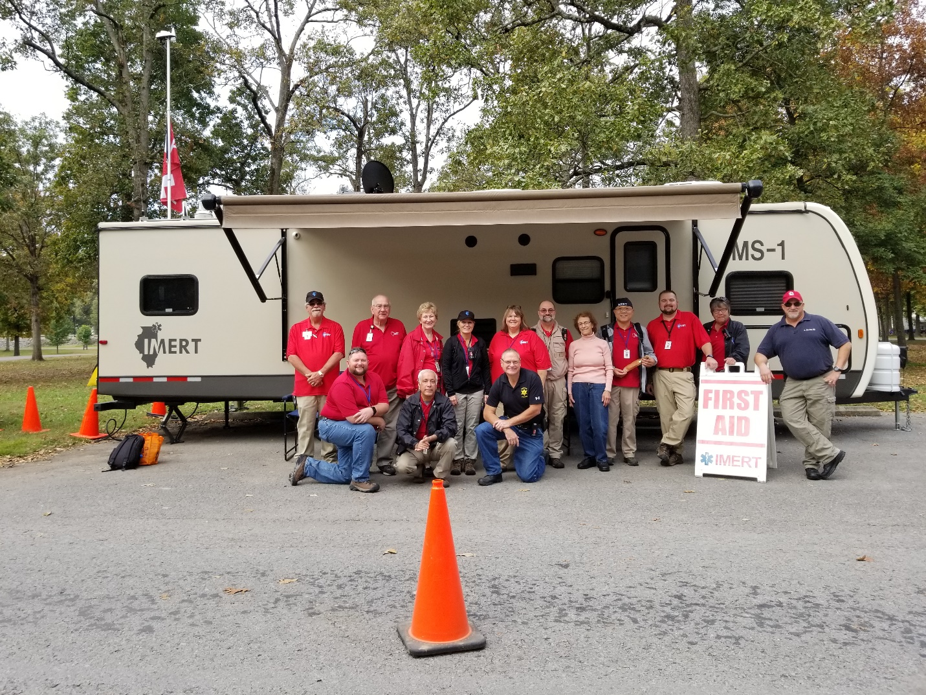

EQUIPMENT
When IMERT is assigned to provide medical coverage at trainings or is deployed, a minimum amount of medical and patient equipment is required. Likewise, responder support requires specific equipment and supplies. The actual needs are dependent on a number of variables that include: nature of incident, anticipated length of deployment, damage to the infrastructure and the number of responders deployed. All of these mobile medical assets require preventative maintenance, and secure storage. Items with electronic components require professional maintenance and storage in a climate controlled environment.
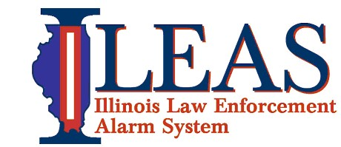
IMERT continues its partnership with the Illinois Law Enforcement Alarm System (ILEAS). The campus contains over 120,000 square feet of safe and secure office, classroom, storage, and training space on a 13-acre campus. The facility and training rooms are utilized for office space, classroom space, and equipment storage, allowing a wider variety of educational opportunities to be offered. ILEAS houses IMERT’s main office and provides secure storage with 24-hour access for volunteer records, program files and equipment. Vehicles and trailers for transport of medical responders, equipment and supplies are used and stored at the ILEAS training facility as well.

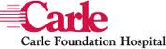
IMERT has continued the MOU with the pharmacy at Carle Foundation Hospital in Champaign-Urbana. The Carle pharmacy department maintains and stores IMERT’s pharmaceutical cache. Maintenance includes rotation of pharmaceuticals by the Carle Pharmacy Department every 3-6 months. An inventory of the pharmaceutical cache is conducted every quarter. The hospital also provides secure, environmentally protected storage, and 24-hour a day access by pre-approved IMERT personnel.
IMERT utilizes a warehouse facility in Urbana to store durable equipment and supplies. This facility provides secure fenced in storage and lighted grounds along with 24-hour access. Video surveillance provides added security. All temperature sensitive materials are stored in a controlled environment and will be ready for roll out as needed. The warehouse spaces have been organized into usage categories to utilize the total storage space effectively and make locating the necessary equipment or supplies easy and efficient.

IMERT maintains an ongoing inventory of all durable and disposable equipment in a computerized inventory system. This includes barcoding items for tracking with handheld scanners for real time supply availability awareness.
Items owned by IDPH that are in IMERT’s custody are inventoried annually. Access to IMERT’s inventory information is available to the Department at any time. The IDPH Inventory was conducted and submitted at the end of March 2018.
Staff is continuously working to improve usability and accessibility of the equipment cache. Currently work is in progress to develop a system to better address a first aid station set up in addition to our current packages designed for Temporary Medical Treatment sites.
PORTABLE ULTRASOUND

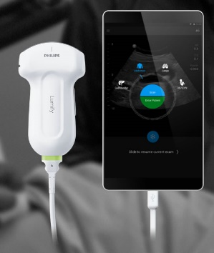
IMERT has obtained a Philips Lumify portable Ultrasound probe. The technology has advanced quite a bit from the days of cumbersome machines and computers. The unit can work with a tablet or a phone on the android based system and is basically plug and go.
This technology is already being used for emergency care around the world. Having point-of-care ultrasound available will be a great advantage, helping to diagnose and treat patients in complicated circumstances. It is a non-invasive, harmless technology that allows patients and doctors more confidence in a stressful situation. It is also very cost effective as, after the initial investment, no further costs are incurred.
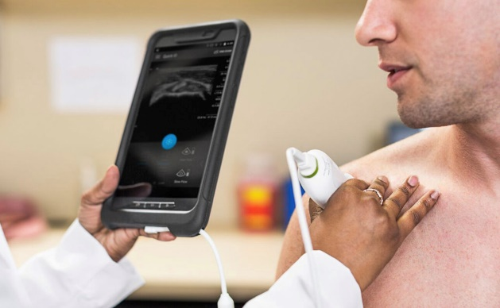
Dr. Moses Lee is in the process of developing training for IMERT’s volunteers in emergency ultrasound. The goal will be to offer useful ultrasound techniques for mass casualty care applications and certain procedures useful for our response team. We hope to be able to offer these training modules to members in the next grant cycle.

EQUIPMENT MAINTENANCE

Preventative maintenance is performed on all equipment including: inspection and maintenance of battery-powered equipment, updates on computers, replacement of bad power supplies and batteries, and added networked and encrypted hard drives. Digital and hard copy records are kept of all work done on the vehicles and equipment and can be made available upon request.
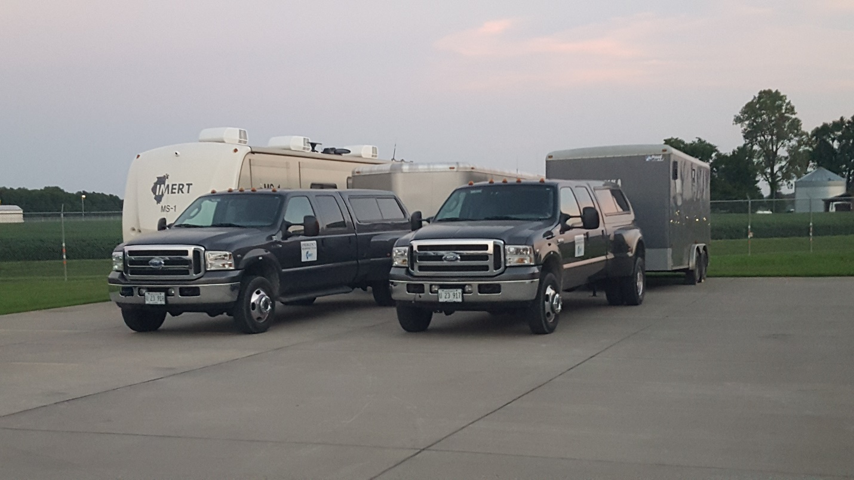
Warranties for extensive maintenance of medical equipment are retained. All Bio-Medical Equipment was maintained per the manufactures recommendations and are certified by an Illinois Licensed Bio Medical technician.
All trailers where maintained to manufacturer standards, two trailers had tires replaced due to age and deterioration. These tires were upgraded to a higher load range tire to handle the weight some trailers may experience and lessen the chance of a blowout due to overheating.

ELLIOTT SYSTEMS DATABASE

IMERT uses the Elliott Data System’s Mobile Solutions platform as its primary volunteer database. The system maintains responder contact profiles as well as credentialing and training information. The system is set up to be redundant with information accessible via the web and hard copied onto two staff computers.
In addition to tracking credentialing information, the system also provides event tracking during training or special events.

COMMUNICATIONS
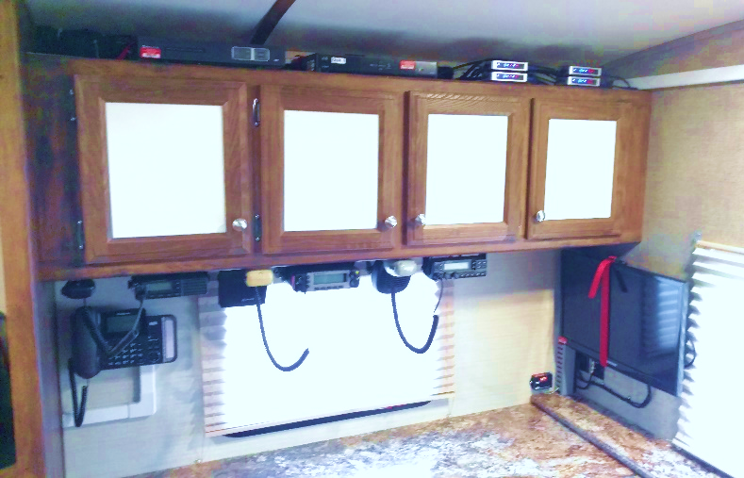
In collaboration with the IDPH Radio Coordinator and the State Interoperable Executive Committee, IMERT developed a radio communication plan. This plan is compliant with the Statewide Communications Interoperability Plan. All StarCom Radios were updated to the new IDPH Template to ensure ongoing communications with IDPH and other state-wide agencies.
Staff and volunteers participated in the Strategic Technology Reserve Team Meeting and Functional Exercise in May at ILEAS.
IMERT added additional capabilities with the addition of Satellite Broadband internet and voice over IP telephone lines to a mobile platform. Mounting the dish and components on a truck with a generator allows complete flexibility to provide phone and internet anywhere it is needed. With the help of ILEAS, ITTF and the Strategic Technology Reserve, the connectivity is being provided at no cost to IMERT.
STARCOM

During previous grant cycles, IMERT has obtained the equipment necessary to ensure interoperable radio communication. This equipment will continue to be maintained for interoperable communication and is used routinely during events and training exercises. Continuous access to StarCom radios are maintained by Dr. Moses Lee, Mary Connelly, Christopher Jansen, and Elizabeth Lee. Star Com radios were utilized on several occasions during the grant cycle:
- Eclipse Deployment in August of 2017 for communications with Region 2 RMERT, Region 4 RMERT and to monitor other channels.
- Fort Massac Reenactment in October 2017
- IMERT StarCom Exercise simultaneously with the team Communications Exercise in February
- IMERT StarCom Exercise in simultaneously with the team Deployment Operations Course in March
- During the telemedicine exercise with EMSC in June.

COMMUNICATIONS EXERCISES

To allow for redundancy in the event of a disaster, IMERT is both able to send alerts to its team members using internal methods and the IDPH sponsored State of Illinois Rapid Electronic Notification System (SIREN)system. Real-time and exercise alerts are conducted using both methods. IMERT’s staff members Mary Connelly and Elizabeth Lee maintain continuous access to SIREN. Two exercises were conducted using the system this grant cycle. These exercises validate that within 24 hours, depending on travel conditions and location of the incident and an authorized State of Illinois request that IMERT can alert, assemble, and deploy in Illinois a Mobile Medical Assessment Team or other medical response teams according to its IMERT Response Packages capabilities policy on file with IDPH.
8/29-30/2017 – Hurricane Harvey Availability Request
Hurricane Harvey is tied with 2005 Hurricane Katrina for costliest tropical cyclone on record, inflicting damage primarily in the Houston Metropolitan area. The actual hurricane struck over a number of days, causing 106 confirmed deaths.
We contacted our team members throughout the state of Illinois after receiving notice from IDPH that medical staff may be needed. The primary objective was to determine

how many of our deployable team members would be able to be deployed, if IMERT was requested to deploy to Harrisburg.
Three phased availability requests were sent out along with informational updates to the IMERT Team.
- 90 percent of team members contacted responded with their availability
- This event tested IMERT’s real time response capability. IMERT volunteers would have been able to staff two phases of weeklong deployments to the affected area.

2/9/18 – Team Communications Exercise
IMERT contacted 159 deployable team members through their wireless contact information and e-mail contact information. Team members were given 48 hours to respond to the availability request. IMERT conducted this exercise using the Health Alert Network’s SIREN system to contact team members and capture responses. 85% of the contacted team members responded to the exercise.

6/22/18 – Team Communications Exercise
IMERT contacted 159 deployable team members through their wireless contact information and e-mail contact information. Team members were given 24 hours to respond to the availability request. IMERT conducted this exercise using the Health Alert Network’s SIREN system to contact team members and capture responses. 87% of the contacted team members responded to the exercise.

COMMUNICATIONS EXERCISE AAR SUMMARY
Strength 1: Involvement of all deployable team members
Strength 2: Team member cellphone and email information was validated
Strength 3: Nearly half of respondents replied within 15 minutes of the initial notification
Strength 4: Members were able to respond within the text and email
Strength 5: High percentage of team participation, with each exercise resulting in higher total participation numbers.

AREAS FOR IMPROVEMENT/ACTION PLAN
Each exercise has improved the response rate, ease of data collection, and team member response accuracy.
1. Staff will compare/contrast utilization of SIREN-I AM RESPONDING-Grasshopper for initial alert, response compilation and subsequent messaging.
2. A message will be sent to all team members that responded to this exercise to let them know results of drill. This was identified as an objective for the last communication exercise but we forgot to do it. Going forward, once we get initial response results we will notify team members, this should happen within 72 hours of the initial alert.
3. Future drills will focus on collection of initial responses at 2-4 hours. Procedure will be developed for subsequent messaging for secondary roll out.
4. Future drills will include a “next step” message that will include staging area and short situational briefing.
5. Next budget cycle, communications drills will be conducted every quarter.

SOLAR ECLIPSE MUTUAL TRAINING EVENT AAR SUMMARY
Exercise Name SIU-Eclipse Medical Team Live Training (Operation Southern Sky)
Exercise Dates 8/20/17 thru 8/21/17
Scope: this document’s focus is limited to the Illinois Medical Emergency Response Team (IMERT) the Region 2 RMERT and the collaboration with Region 5 HCC and Region 4 RMERT during this live training that coincided with the total eclipse of the sun on the campus of Southern Illinois University and at Giant City State Park.
Mission Area(s) Prevention, Mitigation, Response
Capabilities: Foundation for Health Care and Medical Readiness, Health Care and Medical Response Coordination, Continuity of Health Care Service Delivery, Medical Surge
Objectives
1.Participate in pre-event planning with local, regional and state agencies as well as Region 5 HCC, Peoria RMERT and Region 4 RMERT.
2. Identify health hazards and implement measures to decrease impact (prevention)
3. Test multiple communications devices (response)
4. Test collaborative medical operations (response)
Threat or Hazard Potential for increased medical surge/mass casualty event.
Scenario: A Total Eclipse of the sun occurred on August 21, 2017 in southern Illinois. This event drew thousands of visitors to the region. This provided an excellent opportunity to combine medical response resources from Region 5 RHCC and Region 2 Regional Emergency Medical Team (RMERT) and IMERT. Additionally, this event provided an opportunity to include a real-time communications test with Region 4 RMERT.
Participating Organizations: IMERT, Region 2 RHCC and RMERT, Region 5 RHCC, Region 5 IDPH staff, SIH Carbondale Memorial EMS and Hospital staff, Jackson County EMS, Southern Illinois University, Region 4 RMERT.

Summary:
Carbondale Illinois in the southern part of the state was known to be the site for longest duration of the total eclipse on August 21, 2017. The Regional Healthcare Coalition Coordinator from SIH Memorial Hospital had requested IMERT to participate along with hospital staff in a live medical response exercise that would provide the opportunity to blend resources and response capabilities. Understanding that thousands of people would be descending on the area the Region 2 RMERT offered to join in this opportunity to implement mutual aid resources and capabilities. Southern Illinois, like many rural areas of the state does not have the surge capacity that exists in areas of higher population. Many hospitals are designated as critical access and local EMS resources were limited to 9 ambulances in the entire county though numerous medical helicopter resources were available.
Several local events in the surrounding area were planned including a 4-day concert on the grounds of a vineyard, billed as MOONSTOCK, that would feature Ozzie Osbourne as the star attraction on eclipse day. Approximately 12,000 people attended the concert. Another event was planned at Bald Knob Cross of Peace in Alto Pass attended by approximately 700. The event planners provided private medical coverage at these sites. Numerous businesses and vineyards across the region also promoted various eclipse watching events.
The campus of SIU in Carbondale had been marketed internationally as a destination for observing the eclipse. NASA, the Weather Channel and others advertised that they would be on campus and broadcasting live. Saluki Stadium on campus was sold out of all 14,000 ticketed seats. Collaboration with the RHCC, SIU campus officials and local EMS resulted in a combined team of medical responders setting up and operating three first aid stations along the route of heaviest foot traffic. This included the location of two cooling centers adjacent to the stations located in the Arena and the Student Center. Three other cooling center stations were identified and were supposed to be staffed by Student Health staff. These were cancelled the day of the eclipse with no notice. A landing zone was designated on campus for medical helicopter transport. The helicopter was stationed on campus for the first few hours on eclipse day.
Further, local planning and risk assessments identified Giant City State Park as a likely gathering site for hundreds of viewers in a remote area. A mobile medical team was identified from the RMERT and assigned to Giant City State Park at the request of the Department of Natural Resources.

The weather was a factor with temperatures soaring into the high 90’s with high humidity. This was identified as the primary medical concern and proved to be true. Of the 33 patients seen all had symptoms of heat illness.
On campus water availability/distribution became problematic once attendees were let into the Stadium. They were told to dump out their personal water prior to entering the stadium. There was water available for purchase, but the lines were very long and it was rather expensive. Once we became aware of this we contacted campus authorities who lifted the personal water ban.
Other concerns developed regarding the safety of Eclipse glasses as manufacturers recalled hundreds sold on the Internet with concerns about their actual effectiveness in providing protection. Messages were sent out on social media by SIU, NASA, IDPH and others to notify eclipse viewers.
There were initial concerns that traffic congestion would delay EMS transport. During the event this was not a problem, the longest we waited for an ambulance was 10 minutes. Though traffic congestion did prove to be problematic after the eclipse, there was no impact on clinical operations on campus or at Giant City.
Finally, we recognized the possibility of a mass casualty event, either intentional or accidental. We collectively developed contingency plans for this including; identifying the regional EMS Medical Director and other staff to remain at the RHCC offices out at the airport in order to respond with equipment and supplies to wherever they might be needed. Likewise, members of both IMERT and RMERT were identified who could become mobile responders to an event off campus. A truck was designated and outfitted for this purpose. We were made aware of efforts at local hospitals to increase staff and supplies for the day and collaborated with medical helicopter services to identify landing zones and ensure communication interoperability.
This mutual training event was the first of its kind. The combination of resources and personnel from Region 5 HCC, the Region 2 RMERT and IMERT provided multiple opportunities to practice how we can all work together in a disaster. 20 IMERT and 12 Region 2 RMERT volunteers participated. Likewise, we were able to test communications with Region 4 RMERT for situational awareness. The exercise provided multiple opportunities to test planning, communications and medical surge capabilities. A full After Action Report was submitted to IDPH.

